ShopNow is an online shop providing the users with the flexibility to buy and sell products online.

ShopNow is still in progress. Some of the features are presented below:

Visitors can register as a customer or seller

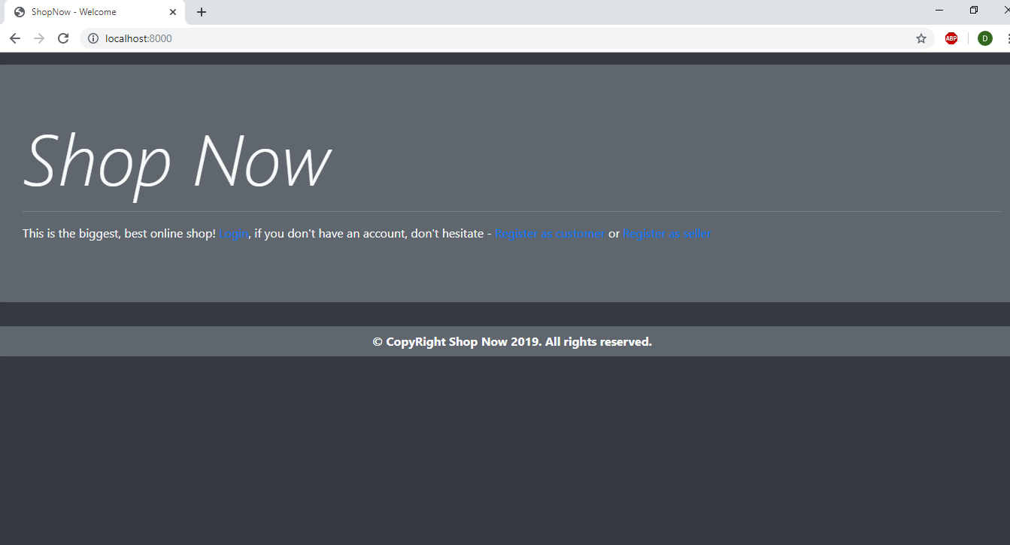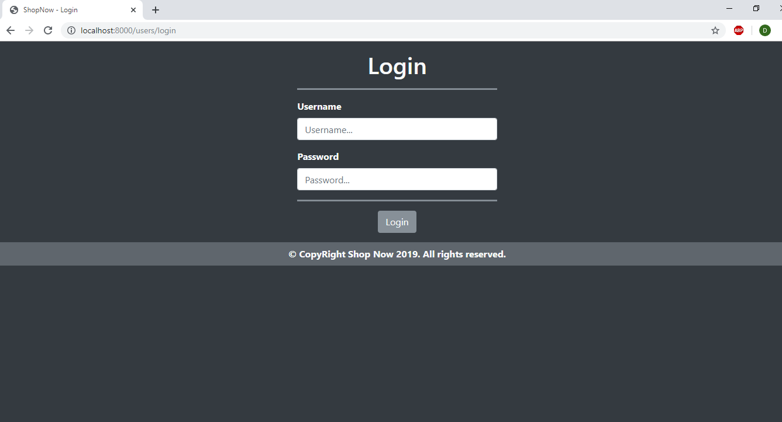

**Customer:**

The customer can purchase products from all around the world and expect them to arrive all at once.

He can view all products by categories.

Register form for the customer:

Visitor must fill his/her first name, last name, address consisting of country name, city, street, postal code and user info – username, password and email. The register form for the seller is a bit different

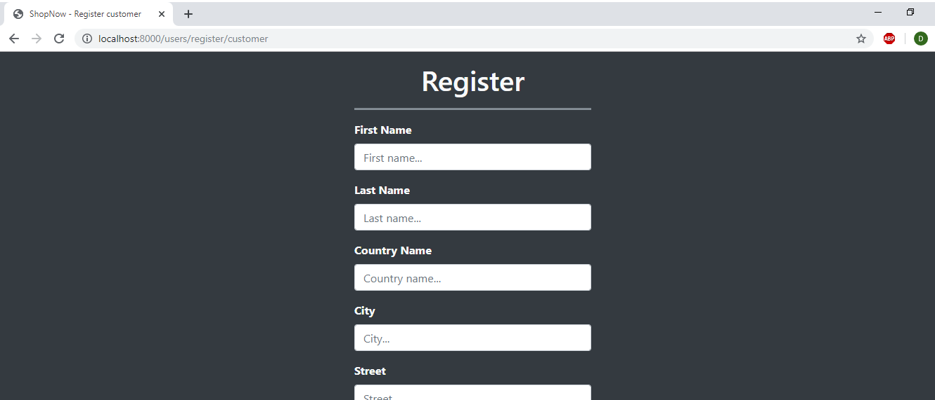

**Seller:**

When logged in as seller on his home page the person can view the requested products that were requested by the orders manager from made orders and the post office address where the seller should send them.

Seller can also create products

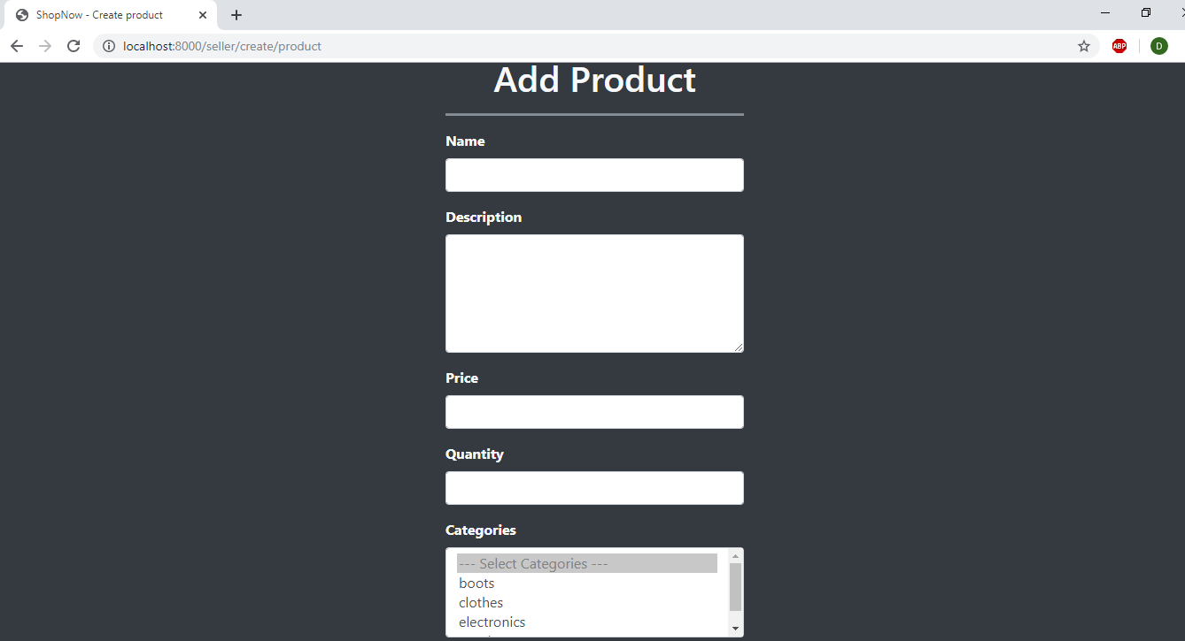

The seller can also view his products:

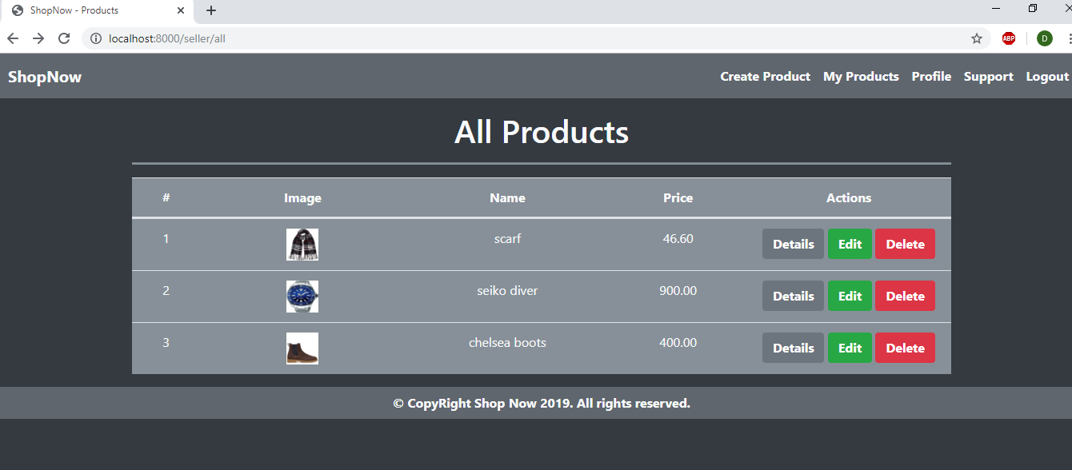

All users except for the administrator can send tickets to the support team

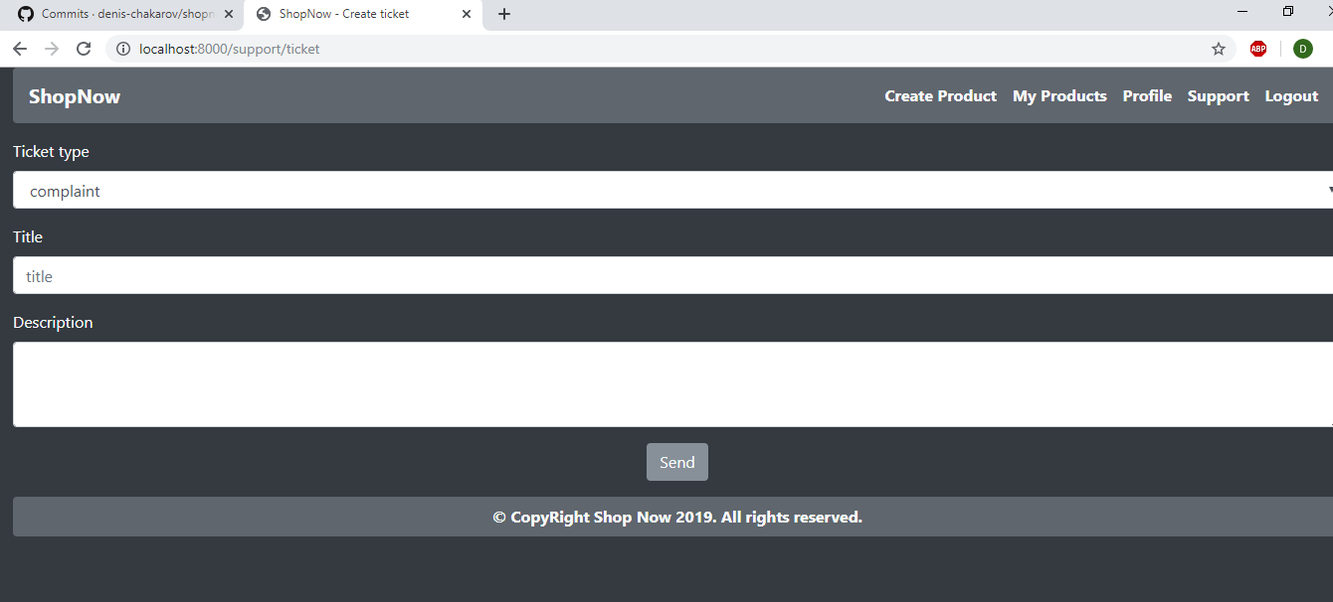

**Orders Manager:**

The orders manager is responsible for notifying the sellers for their products in the orders made by the customers. Every product must be send to a particular post office from the seller. The nearest post office to the seller’s address is the choice where the seller should send his requested products.

There is map of all the post offices around the world that are related to each other forming a graph structure with values on every connection that represents the distance between two offices. After the products from every seller are sent to the particular post offices the manager can calculate the shortest paths from the customer’s address to the post offices where the products were sent to.

The products can be distributed all around the world but at some point of their travel to the customer they meet at a same post office. After calculating the shortest paths the manager can calculate the first common post office where the products meet. That way the manager can have a good feedback when the order should be whole for the first time in case something happens to one of the products.

This can be done for every order.

Here is an example:

The post offices are the red dots and with the lines connecting them it forms a graph structure.

The green circle represents the customer’s address and the light blue circles – the seller’s addresses.

The distances on each connection are omitted in order to keep the simplicity of the model.

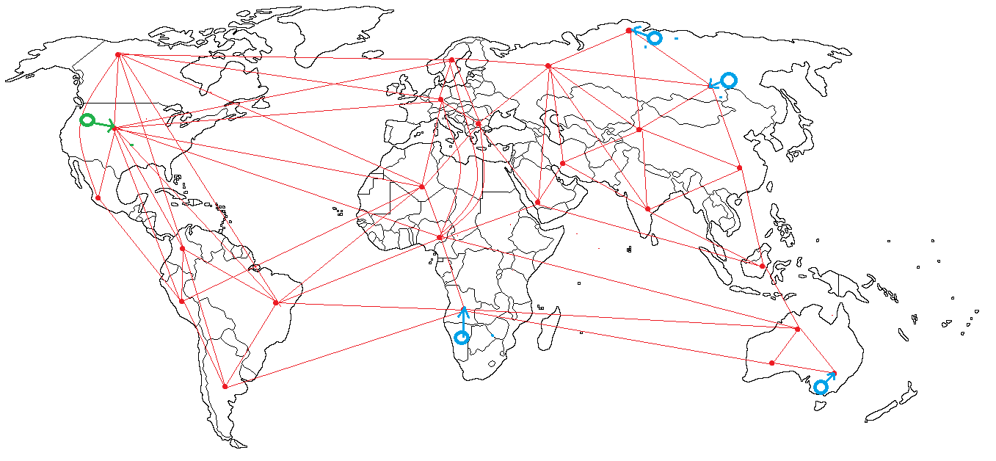

After the products are sent to the nearest post office the Dijkstra algorithm is used for finding the shortest paths from the post office address where the customer should expect the products to arrive (lets call it **Source**) to the post offices of the products.

The result of the algorithm gives us the shortest paths values from **Source** to each of the product’s post offices and also a sequence of names of each office in the particular shortest path.

This information is used to build a shortest paths sub tree structure containing only the shortest paths needed.

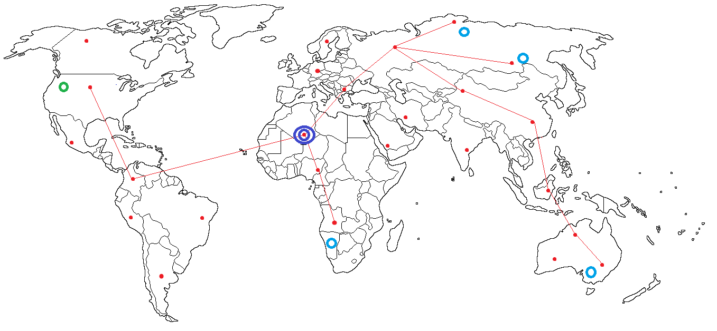

After that LCA (lowest common ancestor) algorithm is performed on the tree to find the first common post office. In this example it’s the dark blue double fenced dot.

The information from these algorithms gives the manager and the customer a good tracking information and state of the order along the way.

**Administrator:**

Some of the things the administrator can do are checking the user activity log, modifying product categories, creating an internal user like support user and orders manager. Future roles include adding post offices, connections between two post offices, banning users.

Activity log: 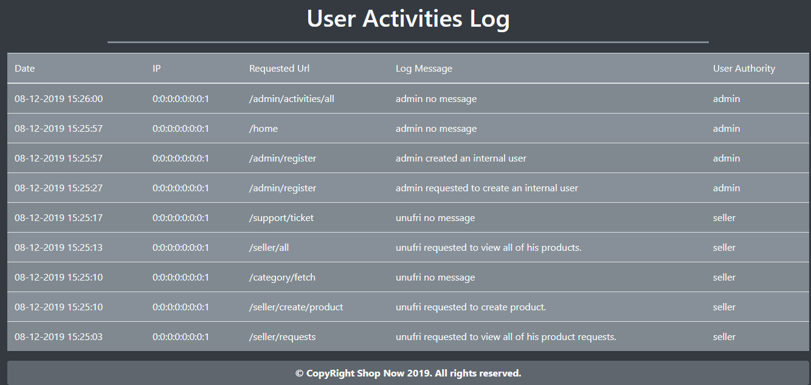

Register an internal user:

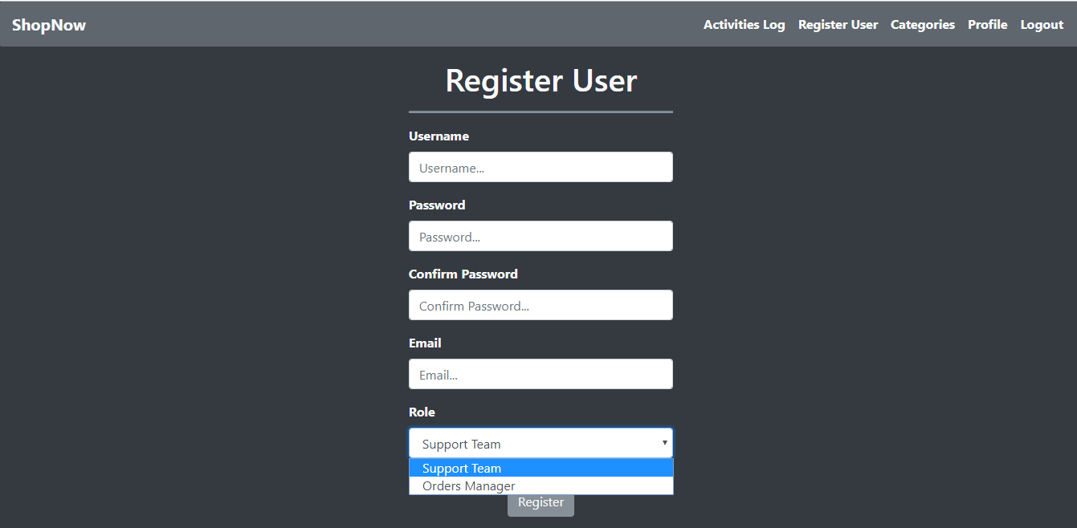

View and modify categories:

